INSERT QUERY OUTPUT
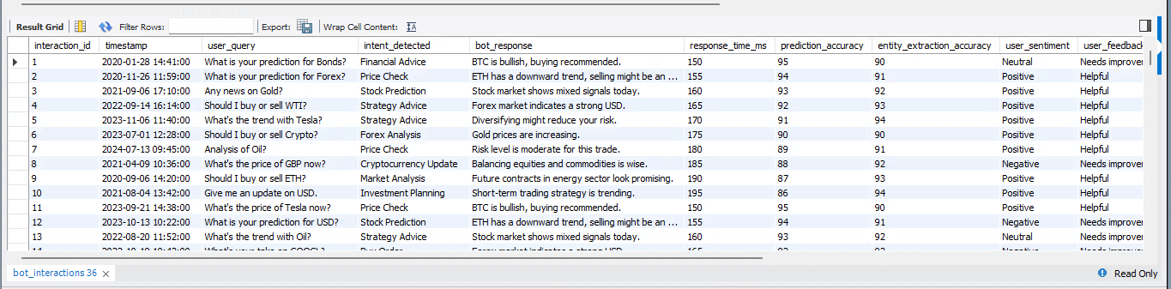

- SQL Queries (For Custom Reports)

- Top 5 Slowest Intents (Average Response Time)
SELECT
intent_detected,
ROUND(AVG(response_time_ms), 2) AS avg_response_time
FROM bot_interactions
GROUP BY intent_detected
ORDER BY avg_response_time DESC
LIMIT 5;

O/P:
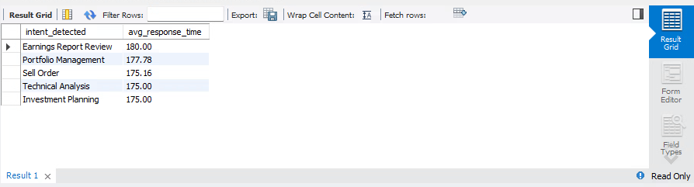
- Feedback Score by Region and User Type
SELECT
region,
user_type,
user_feedback,
COUNT(*) AS total_feedbacks
FROM bot_interactions
GROUP BY region, user_type, user_feedback
ORDER BY total_feedbacks DESC;

O/P:
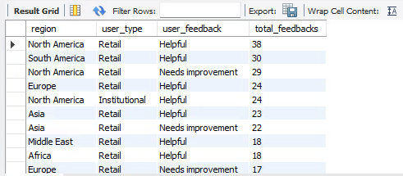

- Intent Accuracy Over Time (Monthly Trend)
SELECT
DATE_FORMAT(timestamp, '%Y-%m') AS month,
intent_detected,
ROUND(AVG(prediction_accuracy), 2) AS avg_prediction_accuracy
FROM bot_interactions
GROUP BY month, intent_detected
ORDER BY month;
O/P:
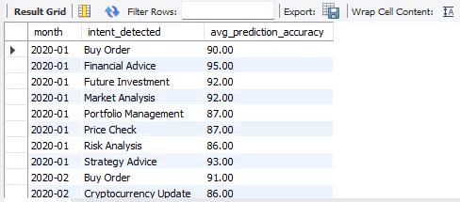
- Failed Conversations (Conversation Success = FALSE)
SELECT
intent_detected,
COUNT(*) AS failed_conversations
FROM bot_interactions
WHERE conversation_success = “Failed”
GROUP BY intent_detected
ORDER BY failed_conversations DESC;
O/P:
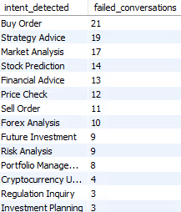
- Cursor + Stored Procedure: Analyze Feedback Per Intent

Task:
For each `intent_detected`, calculate:
* Total interactions
* Helpful feedback count
* Needs improvement count

DROP PROCEDURE IF EXISTS AnalyzeFeedbackPerIntent;

DELIMITER $$

CREATE PROCEDURE AnalyzeFeedbackPerIntent()
BEGIN
DECLARE done INT DEFAULT FALSE;
DECLARE intent_name VARCHAR(100);

DECLARE intent_cursor CURSOR FOR
SELECT DISTINCT intent_detected FROM bot_interactions;

DECLARE CONTINUE HANDLER FOR NOT FOUND SET done = TRUE;

CREATE TEMPORARY TABLE IF NOT EXISTS intent_feedback_summary (
intent VARCHAR(100),
total INT,
helpful INT,
needs_improvement INT
);

OPEN intent_cursor;

read_loop: LOOP
FETCH intent_cursor INTO intent_name;
IF done THEN
LEAVE read_loop;
END IF;

INSERT INTO intent_feedback_summary
SELECT
intent_name,
COUNT(*) AS total,
SUM(CASE WHEN user_feedback = 'Helpful' THEN 1 ELSE 0 END) AS helpful,
SUM(CASE WHEN user_feedback = 'Needs Improvement' THEN 1 ELSE 0 END) AS needs_improvement
FROM bot_interactions
WHERE intent_detected = intent_name;

END LOOP;

CLOSE intent_cursor;

SELECT * FROM intent_feedback_summary;
END$$

DELIMITER ;

CALL AnalyzeFeedbackPerIntent();

O/P:

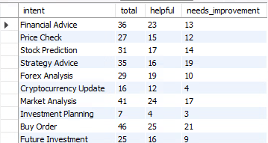

- Function: Response Quality Score (0–1 scale)

DROP FUNCTION IF EXISTS GetResponseQualityScore;
DELIMITER $$
CREATE FUNCTION GetResponseQualityScore(
acc FLOAT,
entity_acc FLOAT,
response_time INT
) RETURNS FLOAT
DETERMINISTIC
BEGIN
DECLARE score FLOAT;
SET score = ((acc + entity_acc) / 2) * (1 - (response_time / 2000.0));
RETURN GREATEST(0, LEAST(1, score));
END$$

DELIMITER ;

SELECT
interaction_id,
GetResponseQualityScore(prediction_accuracy, entity_extraction_accuracy, response_time_ms) AS quality_score
FROM bot_interactions
ORDER BY quality_score DESC
LIMIT 10;

O/P:

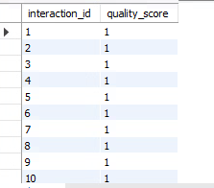

- Report Stored Procedure: Premium Users Only

DROP PROCEDURE IF EXISTS PremiumUserReport;
DELIMITER $$
CREATE PROCEDURE PremiumUserReport()
BEGIN
SELECT
user_id,
user_type,
intent_detected,
COUNT(*) AS total_interactions,
AVG(response_time_ms) AS avg_response_time,
SUM(CASE WHEN conversation_success = “Successful” THEN 1 ELSE 0 END) AS success_count
FROM bot_interactions
WHERE is_premium = TRUE
GROUP BY user_id, intent_detected;
END$$

DELIMITER ;

CALL PremiumUserReport();

O/P:

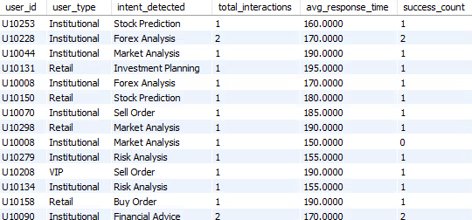

- ADVANCED SQL QUERIES FOR BOT ANALYSIS

- Overall Bot Performance Summary

SELECT
COUNT(*) AS total_interactions,
ROUND(AVG(response_time_ms), 2) AS avg_response_time,
ROUND(AVG(prediction_accuracy), 2) AS avg_prediction_accuracy,
ROUND(AVG(entity_extraction_accuracy), 2) AS avg_entity_accuracy,
SUM(CASE WHEN conversation_success = “Successful” THEN 1 ELSE 0 END) AS successful_conversations,
SUM(CASE WHEN conversation_success = “Failed” THEN 1 ELSE 0 END) AS failed_conversations
FROM bot_interactions;

O/P:

- Feedback Breakdown by Device Type

SELECT
device_type,
user_feedback,
COUNT(*) AS feedback_count
FROM bot_interactions
GROUP BY device_type, user_feedback
ORDER BY device_type, feedback_count DESC;

O/P:

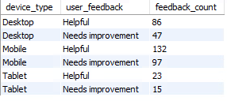

- Peak Interaction Hours

SELECT
HOUR(timestamp) AS hour,
COUNT(*) AS interaction_count
FROM bot_interactions
GROUP BY hour
ORDER BY interaction_count DESC;

O/P:



- Average Accuracy by Region

SELECT
region,
ROUND(AVG(prediction_accuracy), 2) AS avg_prediction_accuracy,
ROUND(AVG(entity_extraction_accuracy), 2) AS avg_entity_accuracy
FROM bot_interactions
GROUP BY region
ORDER BY avg_prediction_accuracy DESC;

O/P:

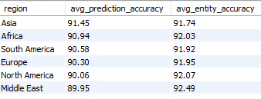

- Intents with Highest Negative Feedback

SELECT
intent_detected,
COUNT(*) AS total,
SUM(CASE WHEN user_feedback = 'Needs Improvement' THEN 1 ELSE 0 END) AS negative_feedbacks,
ROUND(100.0 * SUM(CASE WHEN user_feedback = 'Needs Improvement' THEN 1 ELSE 0 END) / COUNT(*), 2) AS negative_feedback_pct
FROM bot_interactions
GROUP BY intent_detected
HAVING COUNT(*) > 10
ORDER BY negative_feedback_pct DESC;

O/P:

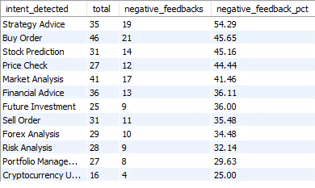

- Premium vs Non-Premium User Feedback Comparison

SELECT
is_premium,
user_feedback,
COUNT(*) AS feedback_count
FROM bot_interactions
GROUP BY is_premium, user_feedback
ORDER BY is_premium, feedback_count DESC;

O/P:

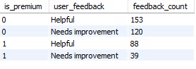

- Sentiment Analysis Distribution

SELECT
user_sentiment,
COUNT(*) AS sentiment_count
FROM bot_interactions
GROUP BY user_sentiment
ORDER BY sentiment_count DESC;

O/P:

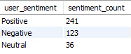

- Average Response Time per Feedback Type

SELECT
user_feedback,
ROUND(AVG(response_time_ms), 2) AS avg_response_time
FROM bot_interactions
GROUP BY user_feedback;

O/P:

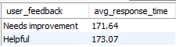
- Top 10 Users with Most Conversations

SELECT
user_id,
COUNT(*) AS conversation_count
FROM bot_interactions
GROUP BY user_id
ORDER BY conversation_count DESC
LIMIT 10;

O/P:

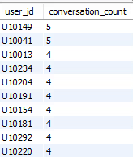

- Device Type vs. Conversation Success Rate

SELECT
device_type,
COUNT(*) AS total_interactions,
SUM(CASE WHEN conversation_success = “Successful” THEN 1 ELSE 0 END) AS successful,
ROUND(100.0 * SUM(CASE WHEN conversation_success = “Successful” THEN 1 ELSE 0 END) / COUNT(*), 2) AS success_rate
FROM bot_interactions
GROUP BY device_type
ORDER BY success_rate DESC;

O/P:

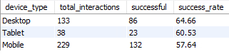

- Account Age Influence on Feedback

SELECT
CASE
WHEN account_age_months < 6 THEN '0-6 Months'
WHEN account_age_months BETWEEN 6 AND 12 THEN '6-12 Months'
WHEN account_age_months BETWEEN 13 AND 24 THEN '1-2 Years'
ELSE '2+ Years'
END AS age_group,
user_feedback,
COUNT(*) AS feedback_count
FROM bot_interactions
GROUP BY age_group, user_feedback
ORDER BY age_group;

O/P:

